Cards for Acting & Describing
You feel faint | You are constipated | You have a rash
You are dehydrated | You have heartburn | You have pins and needles
You have a stiff neck | Your (face/throat/etc.) is swollen | You feel nauseous
You look pale | You have a sinus infection | You are dizzy
Your (arm/face) is numb | You have hay fever | You have a runny nose
Your vision is blurry | You have hives | You have a sore throat
Your lips are dry and cracked. | You have fever and chills. | You are drowsy
Your body aches. | You have asthma | You are pregnant

Start in Hospital  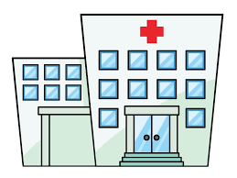 |  | Describe | Act | Describe |  | Describe | You take a sedative. Relax for one turn (lose a turn ) | Act
Act |  | What verb do we use when we pull down on something? |  | Act |  | Unscramble the letters to make a verb:  t-e-x-p-e-m |  | Tongue Twister:  Those thousand thinkers were thinking how the other three thieves got through.
Act |  | Act |  | Describe |  | Describe |  | Act
Describe |  | Go again :) |  | Tongue Twister: If Stu chews shoes, should Stu choose the shoes he chews? |  | What is an adjective that means ‘slightly warm’? |  | What is an expression we use that means, “Please be patient with me?”
Describe |  | What do you put in your mouth to check your temperature? |  | Act |  | Emergency! Go back to the hospital |  | You step on a needle! Go back 10 spaces
Get sick. Lose a turn |  | Talk about your health for 2 minutes |  | What is an antihistamine used for? |  | Act |  | Act
Act | Describe | Act |  | Describe | Act | Describe |  | Finish at Home

