Write the song lyric next to the correct picture.
Laughing all the way | Making spirits bright
On a one-horse open sleigh | Dashing through the snow
Over the fields we go | Bells on bob-tail ring
Jingle bells, Jingle bells, jingle all the way!

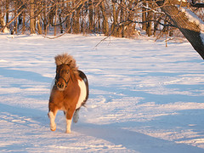
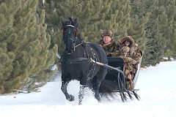
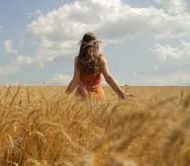
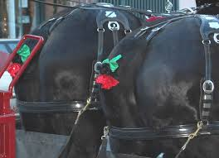
-- downloaded from www.englishcurrent.com --

