1. Label the areas of the webpage below.
1 – URL  2 – Icon  3 – Link/Hyperlink  4. Menu (bar) | 5. Dropdown Menu  6. Profile  7. Scrollbar  8. Widget / Sidebar | 9. Search box  10. Tab  11. Bookmarks Toolbar  12. Back Button  13. Refresh Button
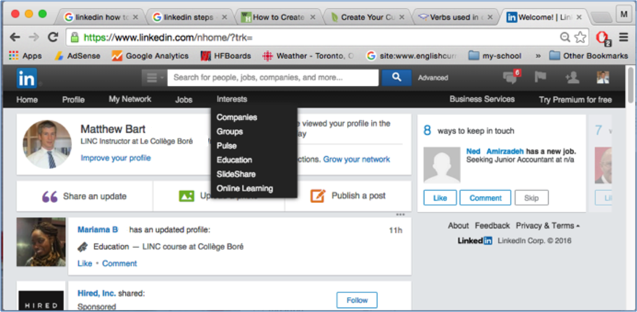
2. Web-Related Verbs
paste log in hover highlight log out scroll copy click cut
Match the above verbs with their definitions below.
To press your mouse button (e.g. Click on the home icon)
To put your mouse over an area on the screen without clicking. E.g. Hover your mouse over the Home Icon
To move up, down on a screen (or sometimes left or right)
To enter your username and password so you can access a website.
To officially exit a website (not by closing it, but usually by clicking the Log Out button)
To use your mouse to select some text. Do this by clicking at the beginning of some text, holding your mouse down, moving to the end of the text, and then releasing your mouse button. E.g. This sentence is highlighted.
To copy some highlighted text or an image. Do this by right-clicking on the text/image, and selecting copy. Or you can highlight the text with your mouse, and then hold down the CTRL+C keys on your keyboard at the same time (for Windows)
The same as copy, but it removes the text/image from its original location.
To put the copied text/image in a new location. Do this by clicking the right mouse button in an area you want to paste your text/image, and then selecting “paste” from the dropdown menu. Or you can press CTRL+V (on Windows)
Information Search:
Answer #1 _________________ Answer #2 _________________ Answer #3 _________________ Answer #4 _________________

